**SOFTWARE REQUIREMENTS SPECIFICATION**

**FOR PREDICTING EMPLOYEE ATTRITION USING MACHINE LEARNING**

Prepared by -

Abhinaya M

Aishwaryalakshmi S

Aksshaya K

Ganesh V

INTRODUCTION:

**Purpose:**

Employee turnover reflects an organization’s internal strengths and weaknesses. The IT industry in India has always been characterized by ungodly hours, monotonous job, and dispirited efficiency resulting in high attrition level. Hence, it has become critical for the companies to satisfy their employees in order to retain them. Organizations face difficulties in retaining the employees as well as attracting potential employees. All this has a significant impact on the strength of a company in managing their business in a competitive environment. The purpose of this project is to predict the number of employees who are likely to leave an organization.

**Project scope:**

This project can help an organization identify the employees who are vulnerable to quitting their jobs. It has scope in any kind of organization.

SYSTEM FEATURES:

**Use case:**

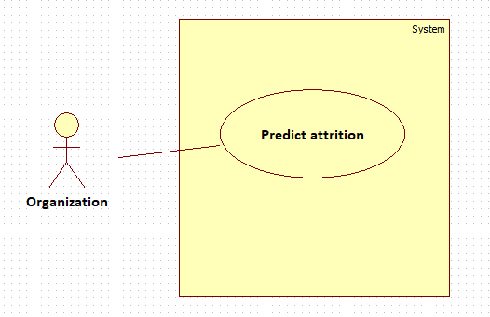

**Name:** Predict attrition

**Input:** Employee dataset

**Output:** Attrition rate

**Pre-condition:** An employee dataset with necessary attributes

**Steps:**

1. Cleaning:

The missing data in the dataset is fixed.

1. Transformation:

The non-numeric attributes are encoded to contain numeric values.

1. Classification:

Various classification algorithms are used to find the number of employees who would leave an organization.

**Post-condition:** The employee attrition rate for the given dataset is displayed